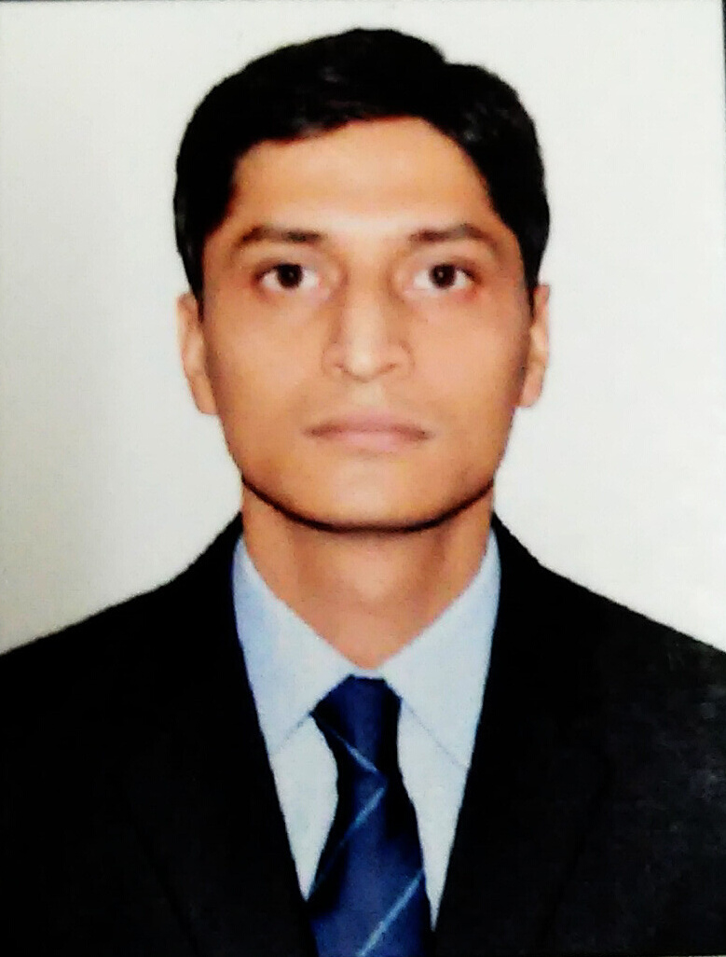

KALLOL MISHRA
7795479523 kallol.mishra.88@gmail.com

Career Objective

Widening the horizons and seeking a position to utilize my skills and abilities in the industry while being resourceful, innovative and flexible.

Work Experince

Name of the organization : WNU Investment Services Pvt. Ltd.
Position Held : Mutual Fund - Research Associate
Duration : Jan-2015 –Till Now
Job Profile : Profiling customers and provide financial product to meet customer needs,
Analyzing the performance of various scheme of client portfolio
Audit of client portfolio
Risk management

Name of the organization : Repeat Solutions Pvt. Ltd.
Position Held : ERP Technical Associate
Duration : 25 Months (Jan-2011to Jan-2013)
Job Profile : Development of various objects as per Technical specification
Reviewing ABAP programs to ensure efficiency and fine-tuning where
necessary.
Preparing test data preparation, analysis, coding and unit testing for various
tasks as per the technical specification.

Educational Qualifications

Qualification | Institution & Place | Specialization | Year of  Passing | Board/ University | Marks (%)
PGDBM | Jain College,  Bangalore | Finance & Marketing | 2015 | EDII | 68.1%
B.Tech | ITME,  West Bengal | Electronics & Communication Engineering | 2010 | WBUT | 67.8%
12th Std. | CMS,  West Bengal | Science | 2006 | WBCHSE | 66.9%
10th Std. | BMHS,  West Bengal | General | 2004 | WBBSE | 75.75%

Certificate Programs

- MS Office Expert

Internship Program
Wudstreet Investment Services, Bangalore From April 2014 – June 2014

Key Results Area

- Analyzing the performance of various scheme of client portfolio
- Audit of client portfolio.
- Risk management
- Study of Performance of PSU Banks Stocks since 2009.

Skills Sets

- Portfolio Management,
- Capital Market,
- Mutual Fund.
- Financial Modeling
- Microsoft Office – Word, Excel, PowerPoint and Outlook.

Personal Details

Date of Birth : 08/12/1988
Gender : Male
Language Known : English, Hindi, Bengali
Hobbies : Reading Economics articles, Watching Political debate.
Permanent Address : Ward No.7,Egra, Purba Midnapore, West Bengal, 721429
Present Address :#101 Gangothri Circle,Near Jaibheema Nagar,6th Cross, BTM 1st Stage,
Bangalore - 68
Marital Status : Single.

